International Debt Analysis

Chiranjeevi Mallavarpu, Ramya Mandava, Sabitri KC, Kim Wong
Southern Methodist University
Dallas

Abstract: The World Bank International Debt dataset provides the detailed picture of debt stocks and flow data on the external debt of individual low and middle income countries. It also showcases other debt data collected and compiled by the world bank so we were able to analyze the statisctics of highest and lowest debt country, the category of highest debt across different countries and check their patterns.we were also able to explore if the income level has any effect on the overall debt of the country.The data was accessed via world Bank data portal https://data.worldbank.org/data-catalog/international-debt-statistics and MySQL on IBM bluemix is used to extract all the insights of this dataset.(summary of the work)

1.Introduction
The International Debt statistics contains more than 200 debt and financial flows indicators for over 130 countries that report public and publicly-guaranteed debt to the World Bank reporting system. The database runs from 1970 to 2016 and pipeline data for scheduled debt service payments on existing commitments to 2024.The database covers external debt stocks and flows, major economic aggregates and key debt ratios as well as average terms of new commitments, currency composition of long term debt, debt restructuring and schedules debt service projections. The dataset includes 5 tables.Total size of data is 155 MB.The database server is MYSQL in Bluemix and total memory size is (5.7.19),1GB.
(background of your work, why your work or this topic is important)

2. Our work
Illustrate our work.
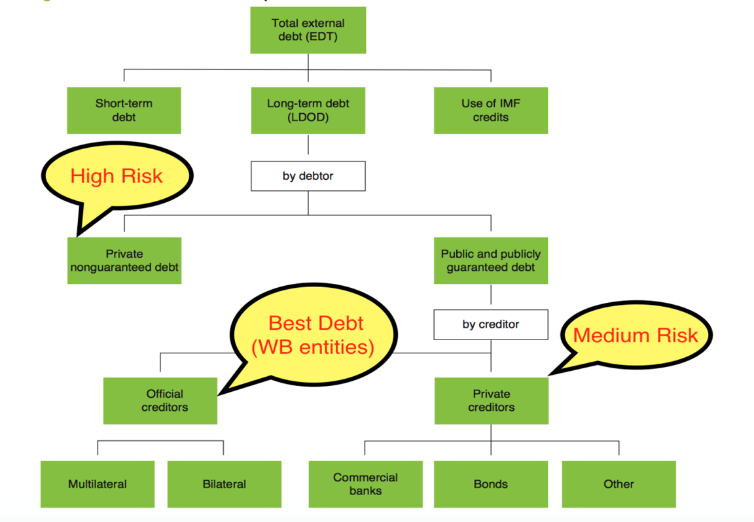

2.1 SQL code link at GitHub:

https://github.com/skc00/DBMS-Term-Project/blob/master/SQLScript_Output.docx

2.2 GitHub link for tutorial:

https://github.com/skc00/DBMS-Term-Project

3. Related / Existing Work
The International Debt dataset is a public dataset from world bank available at https://cloud.google.com/bigquery/public-data/world-bank-international-debt. While the Google analysis is about present value of External Debt(lifetime), we focused on debt outstanding as of year 2016.This is to ensure we have comparable analysis (on the same terms) and minimize the need to make assumptions on what is the relevant rate to discount specific currency, given country-specific circumstances and changes that may happen over the life of the debt. In addition,2016 had the most complete data to date for most countries. We also venture into a new perspective, analyzing metrics such as debts via official creditors vs private non-guaranteed, income level of the country and distribution of most owned debt categories. This will expand our understanding of what kind of debt instrument were widely used and what income level have access to such instruments. (Present the existing work and how it is different from your work.)

4. Conclusion
The International Debt dataset from world bank website was analyzed and found some important insights. On an average long term external debt seems to be highest across all countries. China seems to have highest external debt and Tonga (a Polynesian island) seems to have lowest external debt across all countries. On an average long-term external debt seems to be highest across all countries. (summarize what you have did, why your work is interesting or important, what you have built and what you learned from the work).

References
[1] https://cloud.google.com/bigquery/public-data/world- bank-international-debt#about_the_data.
[2] https://data.worldbank.org/data-catalog/international-debt-statistics

